Home Task 5

## Sales Totals for Photo Products by Quarter

Compose query to retrieve data for report with sales totals for all products in Photo category in Asia (use data for 2000 year). Calculate report totals (TOTAL и YEAR_SUM).

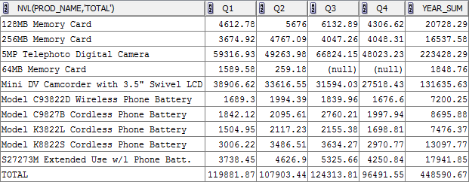

Add into this dataset “delta” fields for calculating differences between quarters. Finally set of columns will be: PROD_NAME, Q1, Q2, DELTA21 (this is Q2-Q1), DELTA21 % (this is (Q2-Q1)/Q1*100), Q3, DELTA32, DELTA32%, Q4, DELTA43, DELTA43%, YEAR_SUM.